Experiment Instructions

In this experiment, you will be paid based upon your decisions and the decisions of the other participants. Therefore, it is important that you understand the directions completely. If you have any questions, please raise your hand and someone will come to your desk.

You are operating a firm.
In today’s experiment you operate a firm that has an old product and can try to develop a new product. Developing the new product requires you to complete multiple steps, but you cannot sell your old product while you are developing the new product. That is, while developing the new product, you must forgo the profit you could have earned by selling the old product. Of course, the new product is more profitable once it is developed.

In today’s experiment, you will be participating in a sequence of markets. Each market will last for a randomly determined number of periods. After any period, there is some probability the market will continue for another period. The right hand side of your screen tells you the likelihood of the market continuing for at least 1, 5 or 10 more periods. A button allows you to “Calculate” the probability of continuing for any number of periods you specify. In the example below, there is 90% chance the market will continue at least for one more period. You can visualize this process by imagining a bingo cage with 90 green balls and 10 red balls. It is as though the computer draws a ball after each period. If the ball is green, the market continues and if it is red the market does not continue. There is a .90⁵ ≈ .59 chance of continuing for at least five more periods, and a .90¹⁰ ≈ .35 chance of continuing for at least 10 more periods. Notice that the probability of continuing for say 10 more periods does not depend on how many periods have occurred. The probability of reaching the 11th period if you are in the 1st period is the same as the probability of reaching the 100th period if you are in the 90th period.

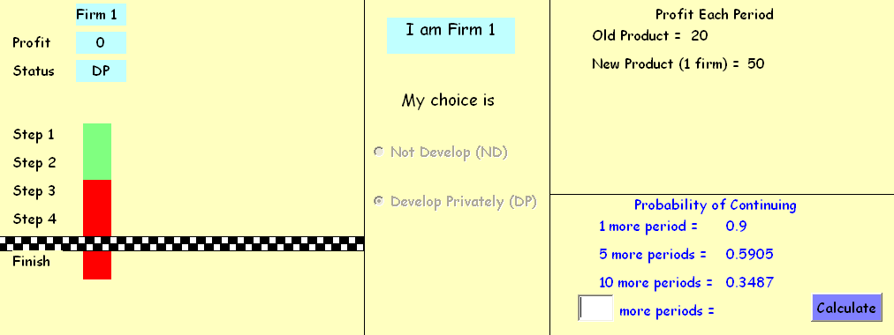

Between periods, you will have 8 seconds to decide if you want to develop privately (DP) or not develop (ND). You can make your choice by clicking the appropriate circle in the center of the screen. If you are successful in developing the new product, the amount of profit you will earn per period is shown on the right hand side of the screen, with the label “New Product (1 firm)”. Note that you will not earn a profit until after you successfully develop the new product and will not earn a profit for the period in which you complete the development. Since the number of periods each market continues for is randomly determined, you might not finish developing the new product by the time that market ends.

If you choose to not develop (ND) during a market period, you will earn the profit from “Old Product” stated on the right hand side of the screen starting that period. Once you choose to not develop (ND), you cannot change your decision for the remainder of the market and thus will earn this amount in all future periods. Keep in mind that you earn 0 each period you choose to develop privately (DP).

How do I develop the new product?
Developing a new product requires that you successfully complete a series of steps. You can complete at most one step in each period. In each period that you are trying to develop the new product, 100 grey cards will appear at the bottom of your screen. You will have 8 seconds to select one card by clicking your mouse on it. If the card turns green, then you have successfully completed the step. If it turns red, you were not successful and will remain at the same step. Your screen will tell you the Probability of Success = #/100 where # denotes the number of green cards. In the example below, there are 25 green cards so there is a 25% chance of success any period. The green and red cards are randomly shuffled each period, so their locations will change.
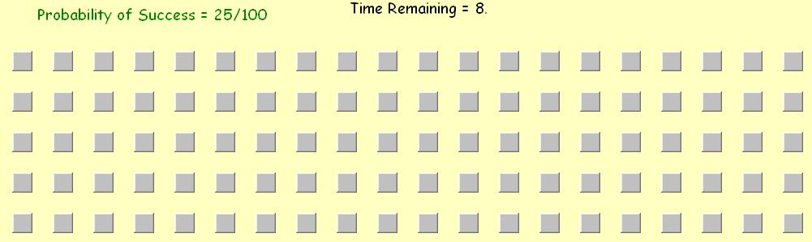
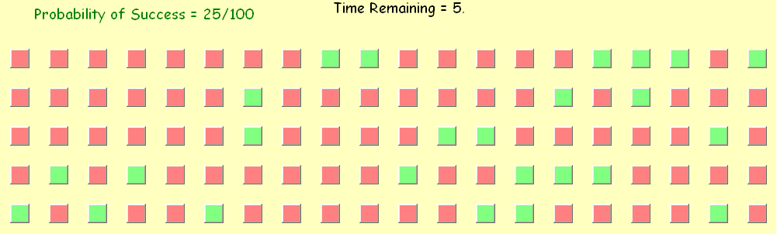

→

→

Looking back at the example on the previous page, the bar on the top left side of your screen shows you what step you are on in the development process and how many steps remain. If a step is green, you have successfully completed it. If it is red, you have not. In the example you have completed Steps 1 and 2 but not Steps 3 or 4. Your current status will be displayed above the bar: not develop (ND), develop privately (DP), or finished (F) if you have successfully developed the new product.

Markets with Multiple Firms
During the experiment, you will operate in a series of different markets each working like the one described above, but some markets will have multiple firms. Your firm number will be displayed on your screen and information about your firm will be highlighted. The other firms will be operated by other participants. Every participant is randomly assigned to a market, so the specific people with whom you interact will change from market to market but not from period to period within a market.

The example screen on the next page shows a situation with 4 firms and 3 steps. In this case, it is possible for multiple firms to develop and sell the new product. The profit for selling the old product is the same for each firm in the market as are the probability of success, the probability of continuing, and the number of steps required to develop the new product.

The profit from the new product depends on how many firms have developed it, but not the order in which they did it. The right hand portion of your screen tells you the profit each period to any firm that has successfully developed the product. In the example on the next page, if two firms have developed the product they would each receive 30, regardless of who developed it first. These two firms would continue to earn 30 each period until a third firm developed the product. At this point, all three would start to receive 20 per period until the market ends by the random rule discussed earlier. Notice that firm 1’s status is (ND) so a fourth firm could not develop the new product in this example.
When there are multiple firms in the market, any and all firms have the opportunity to form a joint venture (JV). Anyone who has selected this option is trying to develop the new product and 1) will have the opportunity to successfully complete the next step and 2) will earn 0 profit that period just as with (DP). However, with (JV), any success is shared among all the firms that have also selected (JV) and are working on the same step.

In the example below, if either Firm 2 or Firm 3 is successful in completing Step 2 in the current period, then both firms will successfully complete that step. Since Firm 4 has selected (DP), Firm 4 will have to be successful on its own to complete Step 2. Firm 1 is already earning a profit as it is has opted for (ND). A firm can switch between (DP) and (JV) between periods, but remember that once you select (ND) you will no longer be able to develop the new product. Notice that profit depends only on the number of firms that have finished development and not on how the development occurred.

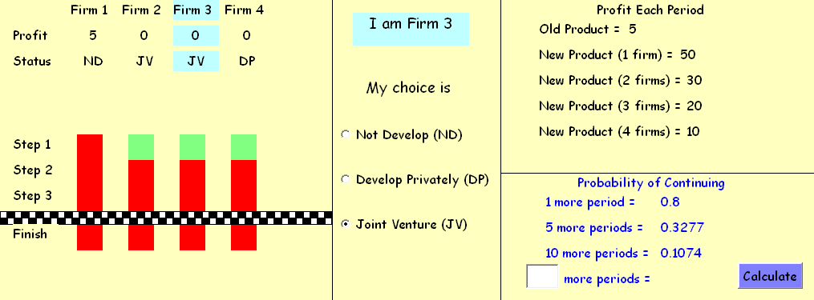

After the first market is completed, a table will appear on the right hand portion of your screen with your firm’s profit for that market. This table will be updated after each market. At the end of the experiment, you will be paid based upon the total profit you earned in all the markets. Your firm’s profits will be converted into $AUS at the rate of 100 in profit = $1, which you will be paid in cash at the end of today’s experiment.

Summary
1. You can earn a profit by selling the old product or by successfully developing the new product.
-You earn a profit with the old product starting the period you select (ND).
-You earn a profit with the new product starting the period after you finish the last step.
-Profit from the new product depends on the number of firms that have finished.
2. The number of periods that a market will last is randomly determined.
3. Successfully completing a step in the development of a new product requires one of the following:
-You selected (DP) and found a green card.
-You selected (JV) and found a green card.
-You selected (JV) and another person on the same step selected (JV) and found a green card.
4. If you choose (ND), you cannot choose (DP) or (JV) in any subsequent period of that market.
5. There will be several markets in the experiment. Profits, number of firms, number of steps, the probability of successfully completing a step, and the probability of a market continuing can change from market to market. The amount you will be paid is your cumulative profit divided by 100.
If you have any questions at this stage, please raise your hand. If you do not have any questions, please answer the following items. Your answers will not impact your payoff. These items are designed to make sure that everyone understands how the experiment works. Feel free to ask questions while answering them.

Q1) Suppose “New Product (1 firm) = 100,” “New Product (2 firms) = 25,” and the profit from the old product is 20. Complete the table below assuming that Firm 1 completes the final step in period 6, Firm 2 completes the final step in period 3, and market ends after 8 periods.

 | Period 1  Profit | Period 2  Profit | Period 3  Profit | Period 4  Profit | Period 5  Profit | Period 6  Profit | Period 7  Profit | Period 8  Profit | Total Profit
Firm 1
Firm 2

Q2) Suppose ““New Product (1 firm) = 100,” “New Product (2 firms) = 25,” and the profit from the old product is 20. Complete the table below assuming that Firm 1 selects (ND) in period 4, Firm 2 completes the final step in period 3, and market ends after 8 periods.

 | Period 1  Profit | Period 2  Profit | Period 3  Profit | Period 4  Profit | Period 5  Profit | Period 6  Profit | Period 7  Profit | Period 8  Profit | Total Profit
Firm 1
Firm 2

Q3) Suppose a particular new product involves 4 steps. If we observe the following behavior in one period, at which step would each firm start in the next period assuming that the market continues?

Firm 1 was on Step 1, selected (JV), and turned over a red card and
Firm 2 was on Step 2, selected (JV), and turned over a green card and
Firm 3 was on Step 2, selected (DP), and turned over a red card and
Firm 4 was on Step 2, selected (JV), and turned over a red card

Firm 1 ________, Firm 2____________, Firm 3____________, Firm 4____________

Q4) If the probably of success is 30/100, there will be _______ green cards and ________ red cards.

Q5) If the probability of continuing for one more period is .6, then the probability of continuing for two more periods is _______ if the market is in period 10 and _________ if the market is in period 40.

Once you answered all of the questions, please raise your hand so that an experimenter can check your responses. After your responses have been checked, please wait silently. The experiment will not begin until everyone has finished going through these instructions at which point a green “Start” button will appear on your screen. When you press this button, the computer will then ask for your name. Your name will not be recorded, but we will use it to call you to receive your payment in private at the end of today’s experiment.

